Name: Provins
Assignment: Module 11 – Django Basics

Screenshot #1 – Default Django page
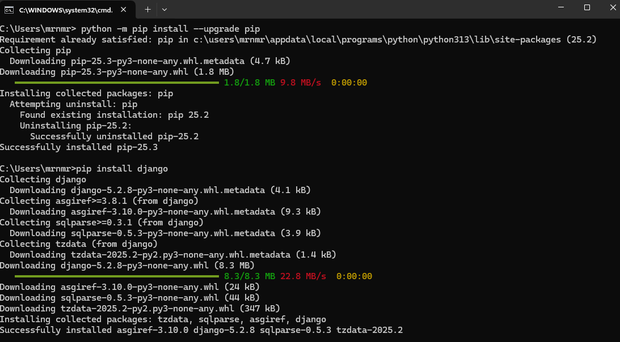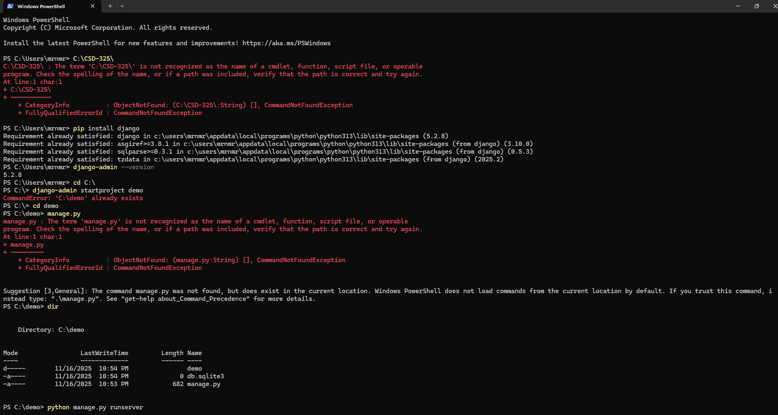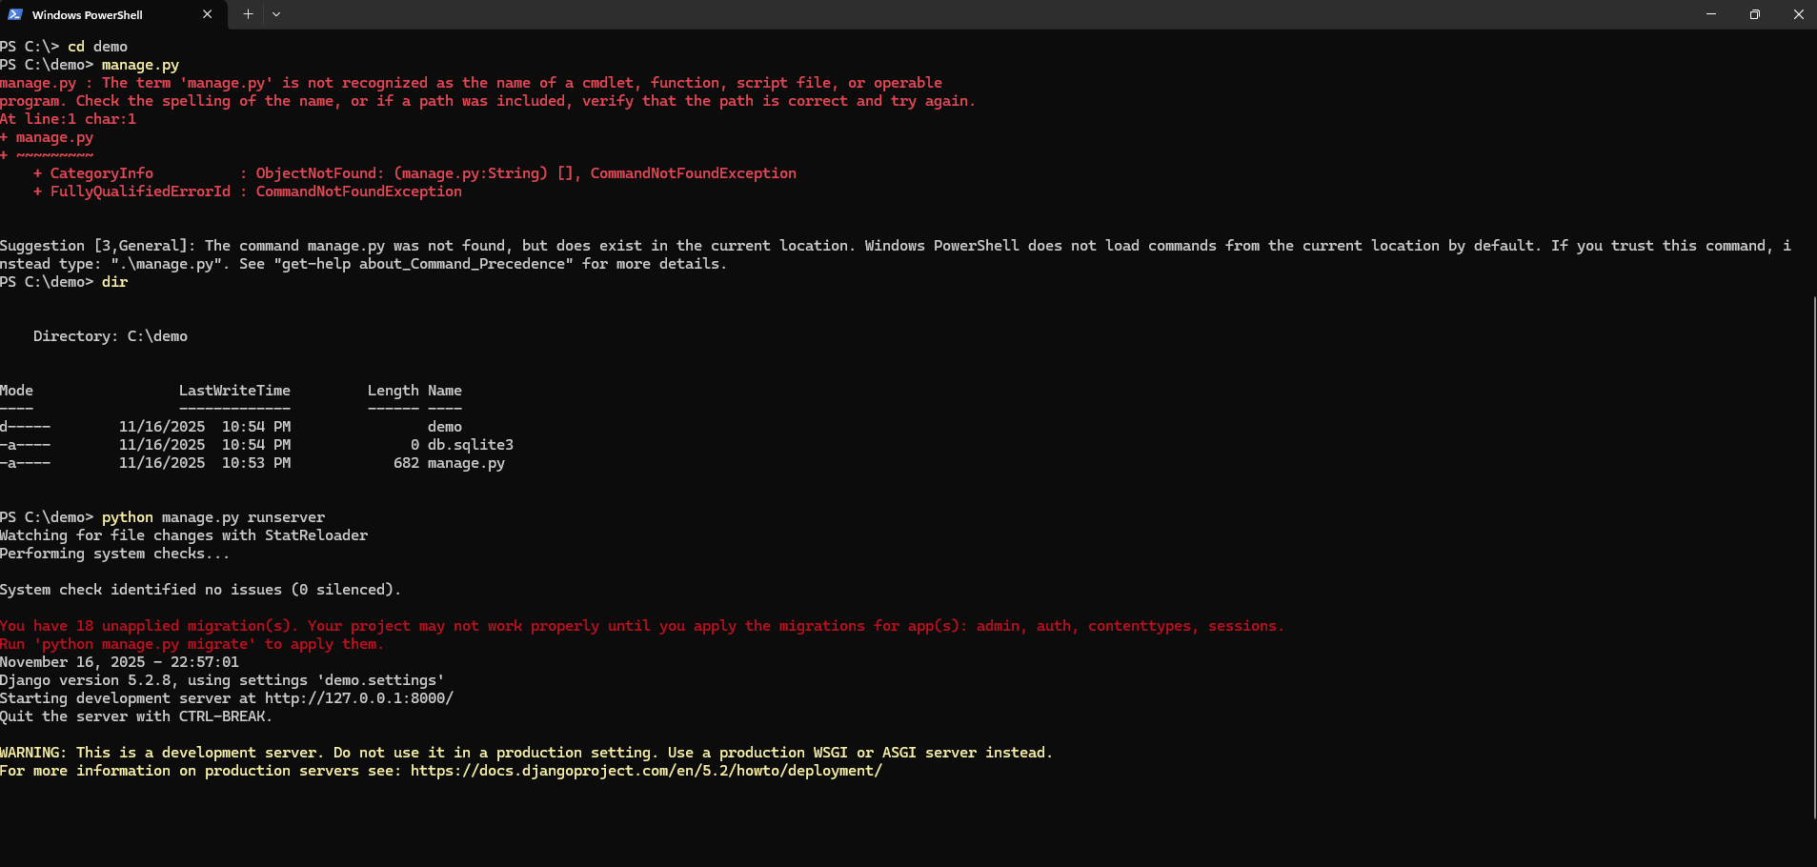
Screenshot #2 – "Provins says Hello!" page
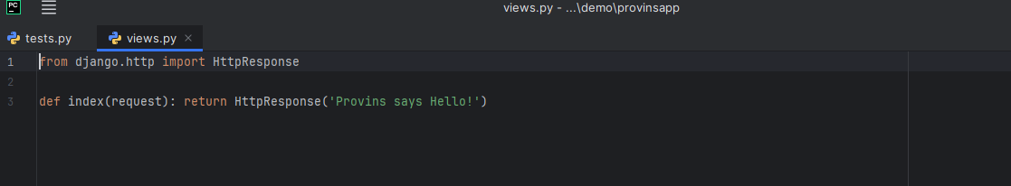
Summary:
I installed Django, created the demo project, created the provinsapp application,
updated the view to show "Provins says Hello!", and verified everything in the browser.

